A.1
CREATE DATABASE CollegeDB;
USE CollegeDB;

CREATE TABLE Course (
CourseID INT PRIMARY KEY,
CourseName VARCHAR(50) NOT NULL,
Fees DECIMAL(10,2) NOT NULL,
);

CREATE TABLE Student (
StudentID INT PRIMARY KEY,
StudentName VARCHAR(50) NOT NULL,
Age INT,
City VARCHAR(30),
CourseID INT,
FOREIGN KEY (CourseID) REFERENCES Course(CourseID)
);
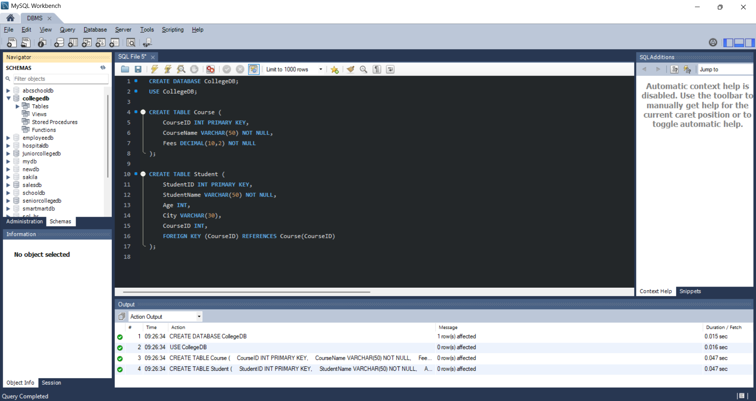

A.2
INSERT INTO course (CourseID, CourseName, Fees) VALUES
(101, 'B.Sc IT', 35000.00),
(102, 'BCA', 40000.00),
(103, 'BBA', 50000.00),
(104, 'B.Sc. Data Science, 60000.00),
(105, 'MCA', 45000.00),
(106, 'B.Com', 60000.00),
(107, 'CSE', 80000.00),
(108, 'MSE', 50000.00);

INSERT INTO student (StudentID, StudentName, Age, City, CourseID) VALUES
(1, 'Amit Sharma', 20, 'Mumbai', 101),
(2, 'Ram Mohan', 21, 'Delhi', 102),
(3, 'Anisa Patil', 22, 'Pune', 103),
(4, 'Rita Nayak', 20, 'Mumbai', 104),
(5, 'Rohan Mehta', 23, 'Delhi', 105),
(6, 'Sneha Joshi', 21, 'Nashik', 106),
(7, 'Arjun Nair', 24, 'Pune', 107),
(8, 'Aditya Ballal', 21, 'Mumbai', 108),
(9, 'Vikas Sharma', 20, 'Thane', 102);
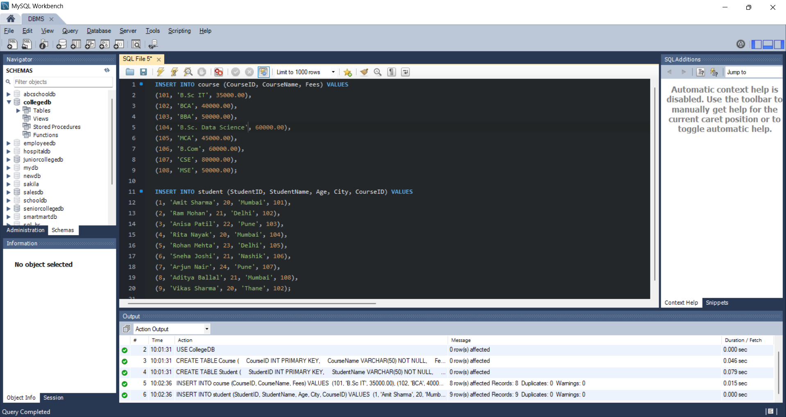

A.3
INSERT INTO Student
(StudentID, StudentName, Age, City, CourseID)
VALUES
(10, 'Rohit Desai', 21, 'Mumbai', 103);
-- Verify: SELECT * FROM Student WHERE StudentID =10;
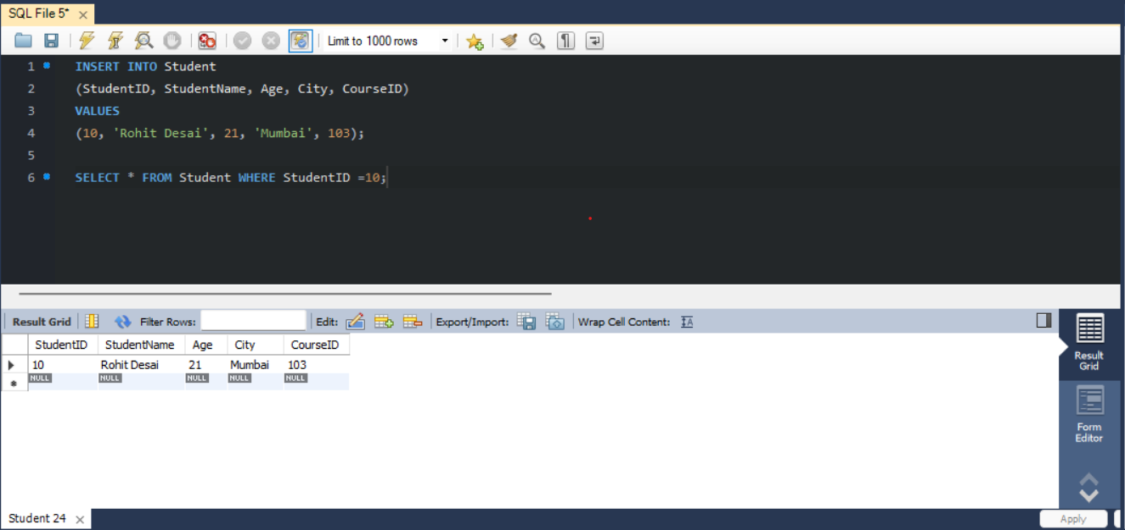

A.4
UPDATE Student
SET City = 'Mumbai'
WHERE StudentID = 2;
-- Verify:
SELECT * FROM Student
WHERE StudentID = 2;
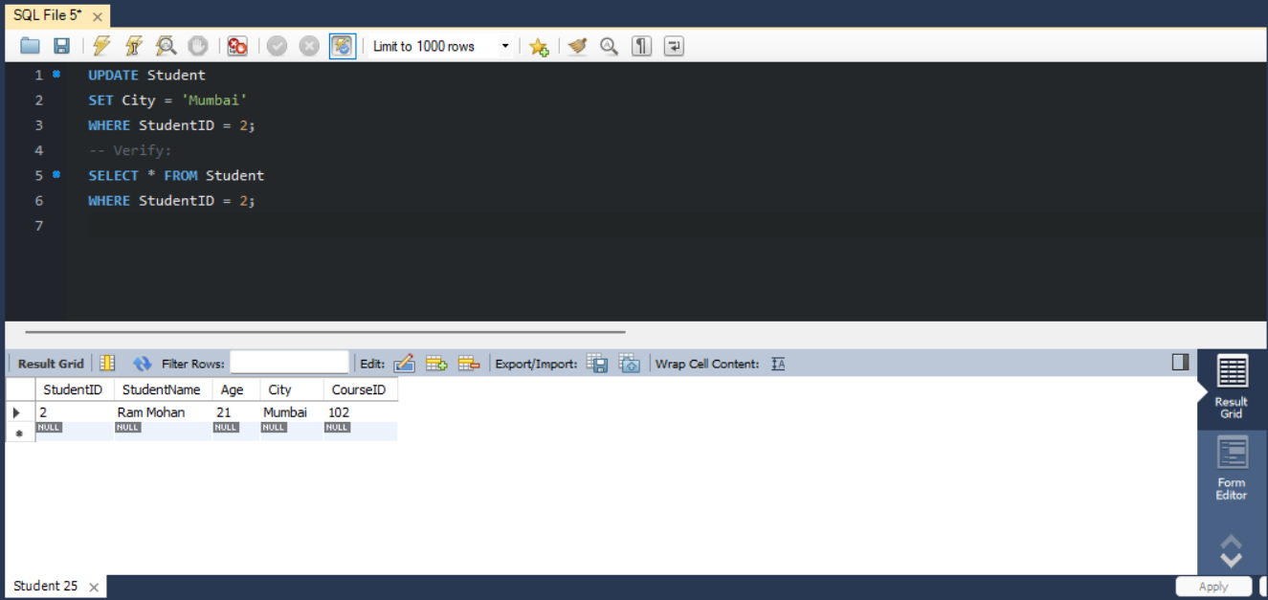

A.5
UPDATE Course
SET Fees = 47000.00
WHERE CourseID = 101;
-- Verify:
SELECT * FROM Course WHERE CourseID = 101;
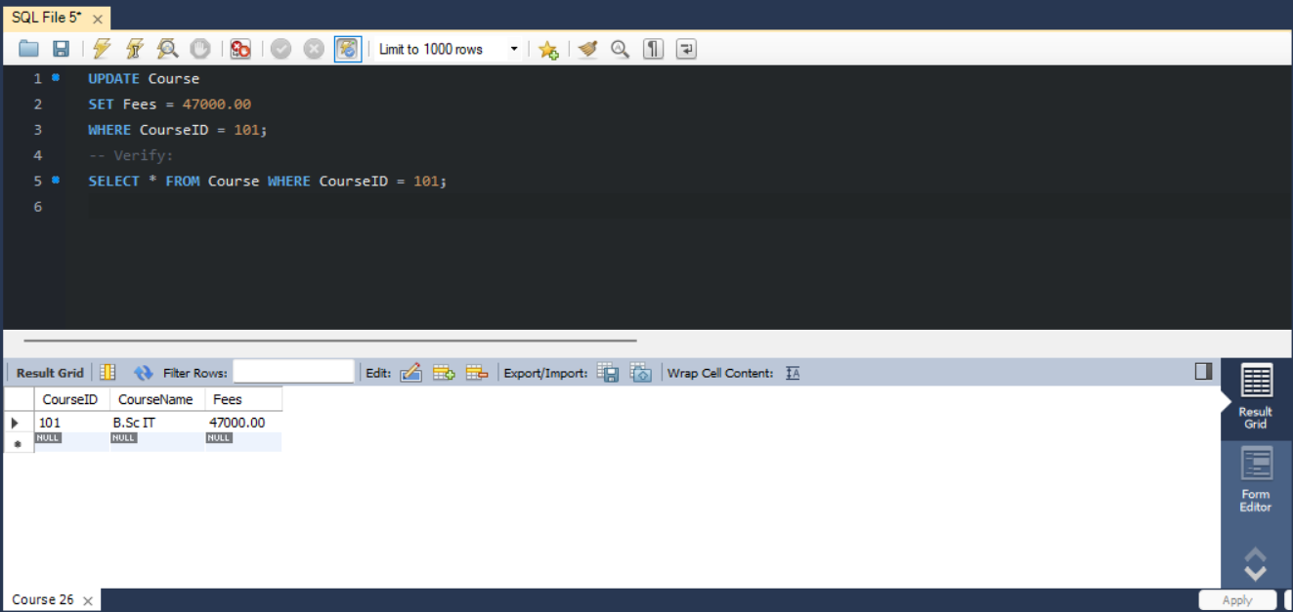

A.6
DELETE FROM Student
WHERE StudentID = 6;

-- Verify:
SELECT * FROM Student;
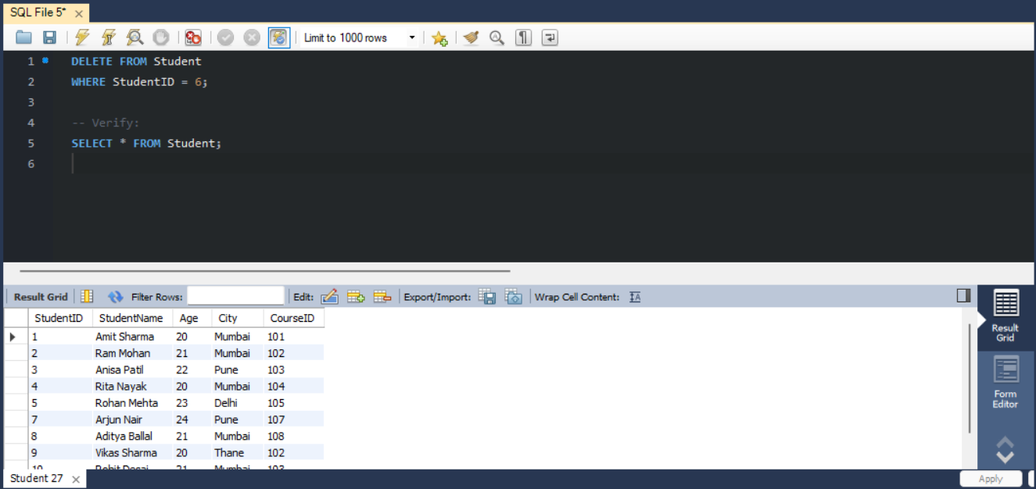

The WHERE clause ensures that only the specified student record is deleted.
Without WHERE, all records from the Student table would be deleted.

